**Axis Vistara Infinite Credit card**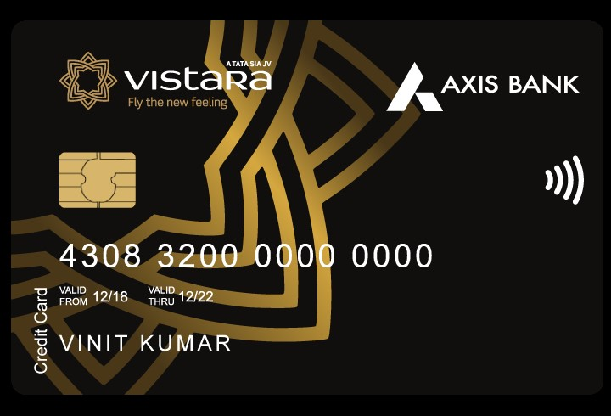

Benefits of Axis Vistara Infinite Credit Card

* Enjoy Exclusive Privileges with Complimentary Club Vistara Gold Membership – priority check-in, priority boarding, additional baggage allowance, priority baggage handling.
  + With effect from 1st March 2024, Club Vistara Gold Membership will be credited basis the predefined conditions mentioned here: https://www.axisbank.com/docs/default-source/default-document-library/credit-cards/revision-in-terms-and-conditions-of-axis-bank-vistara-infinite-credit-card.pdf
* Welcome Reward: Complimentary Business Class Ticket. Continue enjoying this benefit on renewal of your credit card membership every year. Click here for T&Cs: <https://www.axisbank.com/docs/default-source/default-document-library/terms-and-conditions-for-axis-bank-vistara-credit-cards-ticket-voucher-benefit.pdf>
* Club Vistara Points: Earn 6 CV Points for every Rs 200 spent and redeem for upgrades and award flights faster. For options to redeem points , click here: <https://www.airvistara.com/in/en/club-vistara/about-cv#undefined>
* Milestone Spend Rewards: Get Bonus CV Points and up to 4 complimentary Business Class Tickets on achieving milestone spends. To know more, click here: https://www.axisbank.com/docs/default-source/default-document-library/vistara-free-ticket-voucher-tc-final0dabb6b9be576bf08df9ff03000b8c1c.pdf.

For detailed T&Cs: https://www.axisbank.com/docs/default-source/default-document-library/terms-and-conditions-for-axis-bank-vistara-credit-cards-ticket-voucher-benefit.pdf

* Get 6 complimentary rounds of golf at some India’s most picturesque destinations. For details, click here: <https://www.extraordinaryweekends.com/golf>
* Complimentary Domestic Lounge Access per quarter at select airports.: <https://www.axisbank.com/docs/default-source/default-document-library/axis-bank-airport-lounge-access-program.pdf>
* Explore curated experiences from across the world with Extraordinary weekends : <https://www.extraordinaryweekends.com/>
* Avail 40% off upto INR 1000 at partner restaurants across the country with Axis Bank EazyDiner . Visit: <https://dining.eazydiner.com/axisbank> to know more.
* Upto 15% off on Trident properties. To book, click: <https://www.tridenthotels.com/lp/axis-bank-offer/>. For T&Cs: https://www.axisbank.com/docs/default-source/default-document-library/credit-cards/axis-bank-vistara-infinite-trident-offer.pdf
* Get Purchase Protection Cover Up to Rs 1 Lakh. Cover upto USD 300 for the following :
* Loss of documents
* Delay of Check-in baggage
* Loss of Check-in baggage
* T&Cs : https://www.axisbank.com/docs/default-source/default-document-library/credit-cards/vistara-insurance-benefits.pdf
* Get 24x7 Dedicated Concierge Desk – Assistance in flight booking, table reservations, exclusive events/shows, gift deliveries, etc. Click here: <https://campaign.axisbank.com/Generic/Concierge_Service.pdf?_ga=2.189811371.1287839837.1708588189-426301061.1703139234>

How to Apply for Axis Vistara Infinite Credit Card

* User click on the CTA Button or tracking link
* He/She Click Login/Join Now and do OTP verification.
* Select Axis Vistara Infinite Credit Card and provide the required details.
* His/Her application will be submitted, and a confirmation SMS will be sent on approval of his/her application.
* Get His/her application status within 10 minutes.

Documents required for the Application

* PAN Card/Form 60
* ID Proof
* Address Proof
* Bank Statement
* Income Proof

Eligibility Criteria

* Employment status: Salaried or self-employedssss
* Minimum net income should be Rs. 24,00,000 per annum.
* Applicant should be resident of India
* Available across major cities in India
* Age: 21-60 years

Fees and List of all Charges

* Joining Fees: Rs 10,000 + GST
* Annual Fees: Rs 10,000 + GST
* Interest Rate: 3.6% per month (52.86% per annum)
* Cash Withdrawal charges: 2.5% of the cash amount or Min. Rs 500, whichever is higher
* Card Replacement charges: Nil
* Rest charges , you can read here: <https://www.axisbank.com/retail/cards/credit-card/axis-bank-vistara-infinite-credit-card/fees-charges#menuTab>

Important Information

* If user’s Card is disbursed, you will be eligible for commission
* No Rewards if Application is Rejected